Pain & Gain
(This workout is not for beginners)

Chest/Triceps
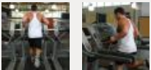
Tip: Make sure whatever you do for cardio, make it light and quick. You don’t want to be too tired to do the rest of the workouts.

Cardio- 5 mins.
- Jog around a track
- Ride a bike
- Shoot around in the gym
Incline
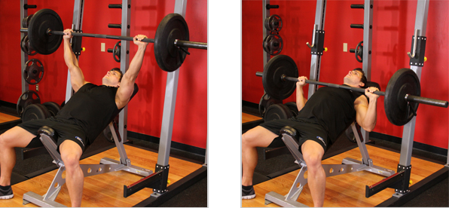
Tip: On the warm-up set focus on doing the motions right and not so much on the weight.
1.1 Warm up set- 12 reps
- 60 sec rest
2. 3 sets- 8-12
- increase weight after each set
- 60 sec rest after each set
3. 1 mixed-grip set- 21 reps
- 3 different grips (wide, chest-width, close grip)
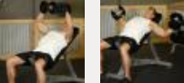
Tip: Make sure to really open up your chest and stretch it while you lift.
Incline Dumbbell Fly’s
1. 3 sets- 8-12 reps
- increase weight after each set
- 60 sec rest after each set
2. 1 Drop set- until failure
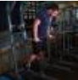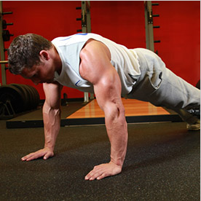
Tip: We are using dumbbells here to try and make your weak arm as strong as your strong arm.

Tip: These sets are supersets. That means there is no rest between these exercises.

Dumbbell Bench Press
1. 4 sets- 6-10 reps
- increase weight after set
- 60-90 rest after each set
Dips/Push-ups
1. 3 sets- until failure
- 60-90 sec rest after each set
Skull Crushers/Close-Grip Bench
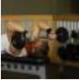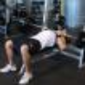
Tip: Slow down and make sure to work out your triceps and not your shoulders. Also these are supersets as well. No rest between exercises.
1. 1 warm up set- 12 reps
- 60-90 sec rest
2. 3 sets- 12-16 reps
- increase weight after each set
- 60-90 sec rest
Triceps Pushdown
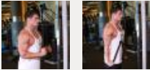
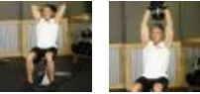
Tip: Focus on flexing your triceps when pull the weight all the way down to your waist.

Tip: Make sure to lock your arms right over your head. A quadruple drop set is when you start off with heavy weight and go until failure. Once you do fail go a little lighter and do the same thing. Do this 4x.
1. 3 sets- 12-16 reps
- 60-90 sec rest
Overhead Dumbbell
1. 1 Quadruple Drop set- Until failure
*Abs
- Abs are optional but recommended
after a tough workout.
- Abs are a little tough to work with because
everyone has to find their own routine that
will help them the best.

Back/Biceps
Tip: Make sure whatever you do for cardio, make it light and quick. You don’t want to be too tired to do the rest of the workouts
Cardio- 5 mins.
- Jog around the track
- Ride a bike
- Shot in the gym
Wide-Grip Pull-ups
Tip: These are to warm up your back before you lift weights. Make sure you try to hit 10 every time. Even if you need some assistants to do so.
1. 4 sets- 10 reps
- 60 sec rest after each set
Bent T-Bar Row
1. 3 sets- 10-15 reps
Tip: Try to pause at the top just to make sure you squeeze your back. The last set make sure to quickly take some weight off and begin your drop set.
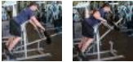
- increase weight after each set
- 60 sec rest after each set
2. 1 Drop set- until failure
Close-Grip Front Lat Pull-down
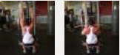
Tip: Try to keep your body still and only move your arms. Drop set, quickly lower weight and knock out as many as you can.

1. 3 sets- 10-12 reps
- Increase weight after each set
- 60 sec rest after each set
2. 1 Drop Set- until failure
One-Arm Dumbbell Row
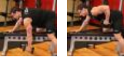
Tip: Focus on throwing your elbow straight back.
1. 3 sets- 8-12 reps
- increase weight after each set
- 60 sec rest after each set
Tip: Make sure to not lean forwards or backwards. Keep arms straight.
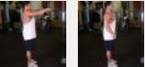
Straight-Arm Pull-down
1. 5 sets- 15 reps
- 30 sec rest after each set
EZ Bar Curl
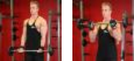
Tip: With light weight focus on form. With heavy weight just do what you can to get it up.
1. 2 strict sets- 12-14 reps
- Little movement
- 60 sec rest after each set
2. 2 cheat sets- 4-6 reps
- Lift heavy
- 60 sec rest after each set
Tips: Focus on bending your elbow squeeze when you get to the top.
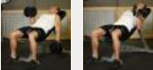
Incline Dumbbell Curl
1. 4 sets- 10-12 reps
- 30-60 rest after each set
Spider Curls/Hammer Curls
Tip: Superset, no break between exercises.
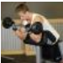
1. 2 sets- until failure
- 60 sec rest after each set

*Calves
- Calves are optional at the end of this
workout.
- The routine is completely up to you

Tyrone Thompson

Styles

I have all of the workouts on the left side of the paper and all of the pictures and tips on the right. I have margins set at .5 inch on all sides. The whole paper is single spaced and 0pt spaced.

I have a title, sub-title, name of the exercise, steps of the exercise, and details of those steps. I also have tips next to each picture of the exercise.

The title is in Font Arial, size 24. The Sub-title is in Font Arial, size 16. The name of each exercise is in font Arial, size 14. The steps within the exercise are Cambria; size 12 same as the details of those steps. The pictures and tips are aligned on the right side of the paper. The tips are all Font Times New Roman, size 8. The pictures are also in a text box and are Justify within those boxes.

These workouts are meant for athletes that have an understanding of the workouts I put down. This is not a workout for beginners that are just trying to get in shape or lose weight. This is for the people that go to the gym to workout out a specific body part, whether it’s for a sport or even a body building competition. Athletes will use my workouts to gain strength and power for any sport they participate in.

